The Nazareth Blue Eagle Education Foundation
WALL OF FAME GALA & SILENT AUCTION
SUNDAY, APRIL 16, 2023
WOODSTONE COUNTRY CLUB
6PM COCKTAIL RECEPTION, 7PM DINNER

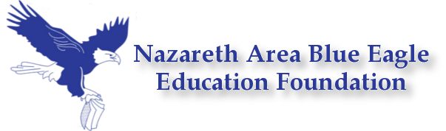
Gala Ticket Order Form

VIP Cocktail Reception & Dinner Tickets are $55 each (or $150 for the Benefactor Level which includes a listing in the Gala Program Book). Checks should be made payable to the Nazareth Blue Eagle Education Foundation and mailed, with this form, to NBEEF, One Education Plaza, Nazareth, PA 18064.
Sponsorship Level: A check is enclosed for the amount of $ for guests.
Listing information for Program Book (for Benefactors Only):
Name(s) of each person attending:
Address: City: State: Zip:
Phone: Email: # of vegetarian meals required
I am unable to attend, but my donation is enclosed.
Tickets are first come, first served until we sell out or through Sunday, April 2, 2023.
Sponsorships & Auction Items are also welcome if you would like to support us in this manner.

The Nazareth Blue Eagle Education Foundation is a 501c(3) nonprofit organization dedicated to raising funds to enhance the academics, arts & athletics in the Nazareth Area School District. Our purpose is to develop, promote and finance programs which supplement and enhance the quality of education and provide the community with extended educational opportunities within the Nazareth Area School District.

The amount of your contribution that is tax deductible for federal income tax purposes is limited to the excess of any money (and the value of any property other than money) contributed by the donor over the value of goods & services received. Dinner value is approximately $40.

For more Foundation information, visit our website and “like” us on Facebook!
http://edfoundation.nazarethasd.org/
https://www.facebook.com/nazarethedfoundation

